Keyestudio Sensor Shield V6 for Arduino

1.Description
Keyestudio Sensor Shield V6 for Arduino is suitable for UNO development board, which can be plugged into the UNO development board without the external power supply.
In the case of retaining the original IO port, the PH2.54 anti-reverse plug terminals are used, which lead to the IO port of the UNO development board. The PH2.54 plug avoids the wrong connection and protects the UNO motherboard and sensors. Furthermore, each IO port is equipped with independent VCC and GND interfaces in a way that make it easier for sensor connection.
The interface of motors, seven-color LEDs and RGB on the car are drawn out, we solely need a wire with anti-reverse plug terminal from the interface on the corresponding bottom plate, which is simple and convenient. In addition, we also reserved some interfaces, IIC, UART, and WIFI interface. It must be noted that this board is powered by the base board 2PIN terminal 5V.

2.Specifications
Current：The maximum is 1.2A (the maximum total current provided by IO of arduino UNO is 200mA, and the maximum is 1A for wifi module)
DC input voltage：5V
Output voltage：DC 3.3V\5V
Maximum power: 4.3W
Recommended ambient temperature：-10°C ~ 50°C
Dimension：70*55*27mm
Weight: 25.5g

3.Schematic Diagram
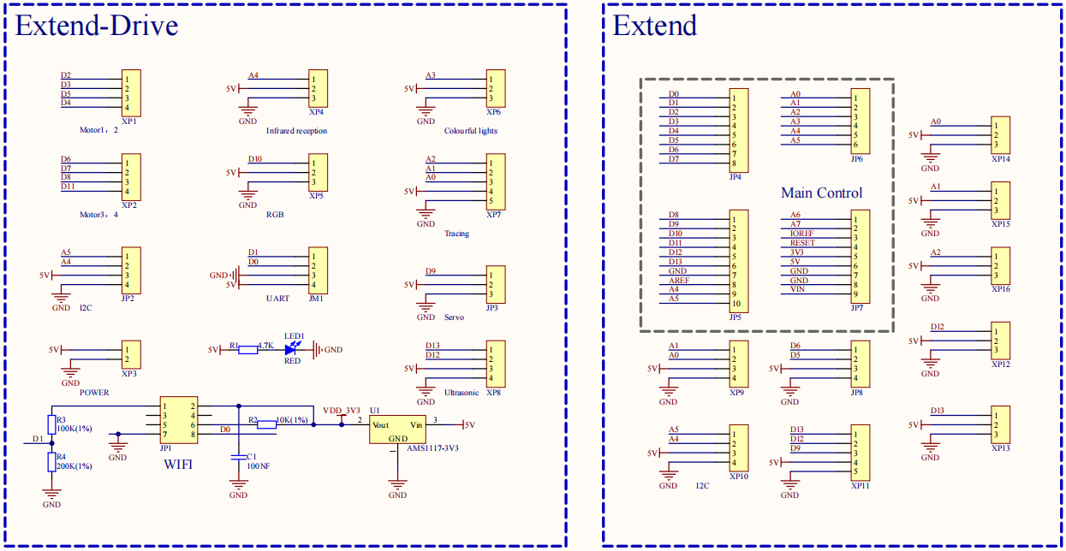

4.Interface
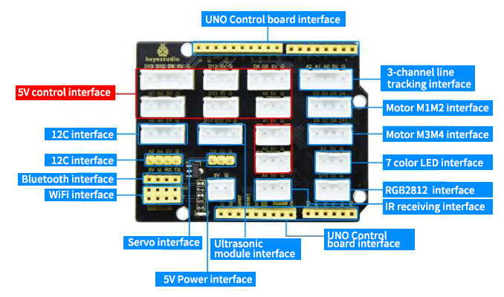

5.Using Method
Stack the expansion board on the Keyestudio UNO PLUS development board, as shown below:

